**2024-2025**

**Hogg Cheer Packet**

**Thank you for your interest in the Hogg Cheerleading Squad**

**Please turn in all required documents by March 1st, 2024.**

* **2 Teacher letters of recommendation**
* **Latest Report Card**
* **Discipline Record (Grade Level Secretary)**
* **Physical (Doctor)**
* **Insurance Waiver (Notarized)**
* **Or $35.00 HISD Insurance**

**Tryout Dates:**

**March 4th – 8th Mandatory Clinic**

**March 18th Tryout Day**

**CHEERLEADER MUST ATTEND EVERY SINGLE DAY OF THE TRYOUT PROCESS!**

**Mandatory Parent Interest Meeting**

**March 1st @5:30pm @ Hogg Gym**

**KEEP THIS PAGE**

**Tryout Attire:**

* **Plain Red T-Shirt (NO Pictures)**
* **Plain Black Shorts (NO Tights or Leggins)**
* **White Crew Socks**
* **White Tennis shoes**
* **Red Bow**
* **Hair (Must be in a Low Ponytail with all hair pulled back, NO bangs)**

**Tryout Times:**

**March 4th- 4:00-6:30pm**

**March 5th -8th 4:00-6:00pm**

**March 18th -4:00- 7:30pm**

**If your Cheerleader makes the squad:**

**Mandatory Parent Meeting and uniform fitting**

* **March 20th 5:30 – 7:30**
* **Mandatory Practices**
  + **July 15th -19th 11:00am – 2:00pm**
  + **August 5th -7th 4:00pm-6:00pm**
  + **August 12th -13th 4:00pm-6:00pm**
* **Starting August 19th Practices will be 6:15am -8:00am**
* **Mandatory Cheer Camp July 25th -28th (If your cheerleader does not attend camp they will forfeit their spot on the team, No Exceptions)**
* **All other info is presented at the end of packet.**

**Hogg Middle School Cheer**

These guidelines are provided to inform students and parents of the expectations of participating in the cheerleading program at HMS. Cheerleaders selected for the cheerleading team must adhere to them during their tenure on the squad. Team members are automatically responsible for these rules and regulations on and after first official practice.

# **Philosophy**

The philosophy of the cheerleading program at HMS has three major goals: to be a support group for all athletic teams by encouraging school spirit; to strive to be a successful competitive program; and to help our cheerleader athletes develop qualities that will enable them to achieve success in all future endeavors.

## **Standards for Cheerleaders**

Cheerleaders by title are role-models. Remember that there are people watching everything you say and do. Because of this, the HMS cheerleaders are expected to set high standards for their school and to set a good example for their fellow students.

To achieve these ends, the cheerleaders will:

* Abide by the provisions of the regulations and the HMS Athletic Code.
* Maintain academic and attendance requirements required by the school guidelines for student athletes.

•Attend all scheduled practices/games/performances, unless it is an excused absence.

* Set an example of good behavior ALWAYS (whether in uniform or not) in class, games, and at all school functions (this includes adhering to the school dress code). 
* Cooperate with each other and follow the instruction of the cheerleading coaches.



**\*Any violation of the rules outlined in this contract will result in one or more of the following consequences administered at the discretion of the cheerleading coach and/or school administration: verbal warning, parent conference, temporary suspension from game(s), or permanent removal from the team**

**Behavior**

* Classroom and social behavior should be always exemplary.
* In any disciplinary action set forth by administration such as ISS/OSS the following punishment will be rendered:

1. ISS-Suspension from practice/game the day of ISS. This will be considered an unexcused absence.

2. OSS-may result in immediate dismissal or long-term suspension from the

team.

* Each squad member will treat coaches, game officials, and other athletics staff with respect always. This attitude should also extend to members of this and other cheerleading squads.
* Coaches' discretion will be final regarding inappropriate behavior or attitude.

# **Attendance**

* Student-athletes must be in attendance at school for at least half a day to be eligible to participate in practice or performances for that day. You must be eligible both by grades and attendance to cheer. Unexcused absences from school will be considered an unexcused absence from practice as well.
* If you are at school, you are expected to be at practice that day. We will, to the best of our ability, put together a schedule to assist each member in arranging their schedules. However, these times are subject to change. As quickly as possible, all changes will be communicated and it's the responsibility of the cheerleader to adjust plans accordingly.
* It is the responsibility of the CHEERLEADER to notify the coach by phone, text or email, of any potential tardy or absence. Unless there is an emergency, significant notification must be provided to allow the coaches to prepare a revised practice schedule. Evey athlete is expected to communicate with the coach, it is important for our cheerleaders to learn to communicate with their coach on their own. (Only in emergencies will the coach accept parent communication regarding absence and tardies)



* Conflicts with work or other extracurricular activities are not valid excuses.
* Members must arrive at practice on time already dressed and ready to warm-up. Unless it's an emergency or the coach is contacted, the entire team will run for late members.
* Practice will usually be 3 to 4 days a week. If practice is not needed parents will be notified.



* Coaches will consider the following acceptable reasons for missed practices, games, and appearances.

1. Injury — The member must still attend practice/games (unless physically unable) but will not participate until medical clearance has been provided. Doctor's notes must be specific in nature of injury and restrictions.
2. Illness —A member may only miss practice with a phone call from the parent (not texting or email) verifying an illness (mild cramps, headaches,  etc. are not considered acceptable illnesses). 
3. Family Emergencies/Funerals.
4. Class requirement that cannot be fulfilled at another time.

*Failure to contact a coach about missing practice for any reason will result in an unexcused absence and possibly removal from the team.

**The coach has the discretion to remove a cheerleader from the team for excessive tardiness and poor attendance**.

**Practice Expectations**

Practice attire includes tennis shoes, shorts, t-shirt, hair up in a secure ponytail. This must be taken care of before practice time. Bring all medical needs (inhalers, insulin pumps, epi pins, etc.) to all practice and games.

* Remember, practices are closed to family and friends. Showcases will be scheduled for friends and family to watch.
* Please be on time. If consistent tardiness and absences is a problem, it could mean dismissal from the team.
* Cell phones should be turned off and given to the coach prior to practice.Phones may not be checked during water breaks.

**Game Expectations**

* Arrive early. Due to safety reasons, you will be benched for a portion of the game if you are excessively late, regardless of the excuse. Members may not leave the game early without prior approval.
* If a cheerleader Miss a game, they will not be able to cheer the next game (but is still required to attend) If student does not attend It will be considered another missed game and will be removed from the team for excessive absences for mandatory events. Missing games is unacceptable.
* Members must ride to and from away games with the team unless prior written approval is on file with the athletic department. Cheerleaders are to remain in the cheering area during the game. DO NOT socialize with players, crowd members, or parents during the game. During football cheerleaders will not be allowed to leave the cheering area for halftime UNLESS COACH GIVES PERMISSION.
* Cheerleaders must have natural nails and natural hair colors during the season, any violation of this rule will result nonparticipation in all games and performances.
* Perform only the cheers that have been perfected and approved by the coach.
* Uniforms will be returned to the coaches after the game every week. If it was not purchased by self.

**Coach's Discretion**

All Razorback cheerleading rules will be interpreted and carried out by the HMS cheer coaches, under the guidance of the HMS Administration. **Any Infractions of any Kind will be penalized under coaches’ discretion**.

***Cheerleader Payment List***

|  |  |
| --- | --- |
| Uniform Packet | $780.00 |
| Cheer Camp July 25th-28th | $200.00 **Paid!** |
| Food: Basketball/Football | $120.00 |
| Water Tumbler | $45.00 |
| Sports Camp | 50.00 |
|  | Member Total $ 995.00 |
| Competition Fee | $150.00 (or Parent Volunteer) |
| T shirts: Football/Basketball | $20.00 (Optional) |
|  |  |
| Mascot Fee | $165.00(Can Change) |

Payment Plan Due dates

1st Payment: April 1st (Will pay through Cheerleading.com website and send confirmation email to coach Skinner)

**(Member Fee = $ 390.00)**

2nd Payment: May 1st (Will pay through Cheerleading.com website and send confirmation email to coach Skinner)

**(Member Fee = 390.00)**

3rd Payment: June 1st ($45 Cash Only to Coach Skinner and $50 to School Pay)

**(Member Fee = $ 95.00)**

4th Payment: August 14th (Cash Only to Coach Skinner)

**(Member Fee = $ 120.00)**

*(Parent must Volunteer for the Homecoming Dance for the Competition fee to be waived)*

***We will fundraise for competition fees.***

***Please Have money in by Due Date. No refunds will be given.***



**Stephanie Woods ~ 281.451.6986 ~ swoods@cheerleading.com Erin Woods, Sales Assistant**

**Hogg Middle School / Cassandra Skinner 4-24 Girls**

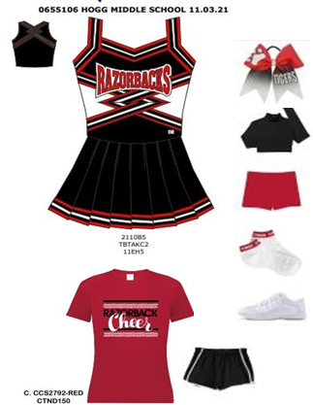

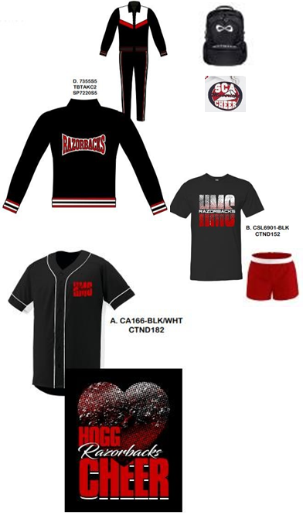

**CHEERLEADER LETTER OF RECCOMENDATION**

Name of Student: ____________________________________________ Grade Level: _________

Referral Person/Title: _________________________________

**Can be filled by Hogg Teachers ONLY**

|  |  |  |  |  |  |
| --- | --- | --- | --- | --- | --- |
| **Student Assessment** | **Exceptional**  **5** | **Above**  **Average**  **4** | **Average**  **3** | **Below**  **Average**  **2** | **No Basis for**  **Judgment**  **1** |
| Academics |  |  |  |  |  |
| Punctuality |  |  |  |  |  |
| Initiative |  |  |  |  |  |
| Attitude towards teachers |  |  |  |  |  |
| Behavior |  |  |  |  |  |
| Leadership ability |  |  |  |  |  |
| Attendance |  |  |  |  |  |
| Work ethic |  |  |  |  |  |
| Oral Expression |  |  |  |  |  |
| Overall recommendation |  |  |  |  |  |

NOTE: Your comments are most beneficial in the total selection process!

Why would the candidate make a good candidate for Hogg Cheer Squad?

_________________________________________________________________________________

_________________________________________________________________________________

_________________________________________________________________________________

_________________________________________________________________________________

Recommender’s Name (Please Print) Recommender’s Title

_______________________________ _____________________________

Recommender’s Signature Date

_______________________________ _____________

**CHEERLEADER LETTER OF RECCOMENDATION**

Name of Student: ____________________________________________ Grade Level: _________

Referral Person/Title: _________________________________

**Can be filled by Hogg Teachers ONLY**

|  |  |  |  |  |  |
| --- | --- | --- | --- | --- | --- |
| **Student Assessment** | **Exceptional**  **5** | **Above**  **Average**  **4** | **Average**  **3** | **Below**  **Average**  **2** | **No Basis for**  **Judgment**  **1** |
| Academics |  |  |  |  |  |
| Punctuality |  |  |  |  |  |
| Initiative |  |  |  |  |  |
| Attitude towards teachers |  |  |  |  |  |
| Behavior |  |  |  |  |  |
| Leadership ability |  |  |  |  |  |
| Attendance |  |  |  |  |  |
| Work ethic |  |  |  |  |  |
| Oral Expression |  |  |  |  |  |
| Overall recommendation |  |  |  |  |  |

NOTE: Your comments are most beneficial in the total selection process!

Why would the candidate make a good candidate for Hogg Cheer Squad?

_________________________________________________________________________________

_________________________________________________________________________________

_________________________________________________________________________________

_________________________________________________________________________________

Recommender’s Name (Please Print) Recommender’s Title

_______________________________ _____________________________

Recommender’s Signature Date

_______________________________ _____________

**Please make sure you add a copy of each of each of the required documents before turning in the packet, everything will be checked.**

* **2 Teacher letters of recommendation**
* **Latest Report Card**
* **Discipline Record (Grade Level Secretary)**
* **Physical (Doctor)**
* **Insurance Waiver (Please get Notarized)**
* **Or $35.00 HISD Insurance**